# CMSC 345

### Software Design and Development

UMBC-CMSC 447 Section 2 Team 4

Team Awesome

# Planes for Hire

**System Requirements Specification**

Client: John Winder

Member: Sundar Sekar <[ssekar1@umbc.edu](mailto:ssekar1@umbc.edu)>, Tam Tran <[tamtran1@umbc.edu](mailto:tamtran1@umbc.edu)>,

William Cahill <[wcahill1@umbc.edu](mailto:wcahill1@umbc.edu)>, Roberto Melgar <[rmelgar1@umbc.edu](mailto:rmelgar1@umbc.edu)>,

Du Nguyen <[du2@umbc.edu](mailto:du2@umbc.edu)>

2/12/2015

# 

[Planes for Hire]

System Requirements Specification

**Table of Contents**

1. Introduction

1.1 Purpose of This Document

1.2 Purpose of the Product

1.3 Product Scope

2. Functional Requirements

2.1 Use Case 1

2.2 Use Case 2

2.3 Use Case 3

2.4 Use Case 4

2.5 Use Case 5

2.6 Use Case 6

2.7 Use Case 7

2.8 Use Case 8

2.9 Use Case 9

2.10 Use Case 10

2.11 Use Case 11

2.12 Use Case 12

2.13 Use Case 13

2.14 Use Case 14

2.15 Use Case 15

3. Non-Functional Requirements

4. User Interface

5. Deliverables

6. Open Issues

7. Appendix A – Agreement Between Customer and Contractor

8. Appendix B – Team Review Sign-off

9. Appendix C – Document Contributions

## 1. Introduction

# 1.1 Purpose of This Document

This document is designed to explain the features of our renting plane web application, it’s functions, and the conditions required for operation. The intended audience is the the customer, John Winder and ourselves, the development team.

# 1.2 Purpose of the Product

This application is designed to let customers rent out planes and travel to anywhere they want to in the the United States of America. Renting and travelling by plane will be simplified by the webserver, as it keeps track of who rents a plane, where his or her destination is, and what planes are available based on the user’s location.

# 1.3 Product Scope

The Planes for Hire application consists of nine use cases including: Google Maps API, clickable pins, planes, airports, user login, account protection, avatars for users, search function, late penalties, and many more. Please refer to figures 1-17 below for further understanding of actions available to users.

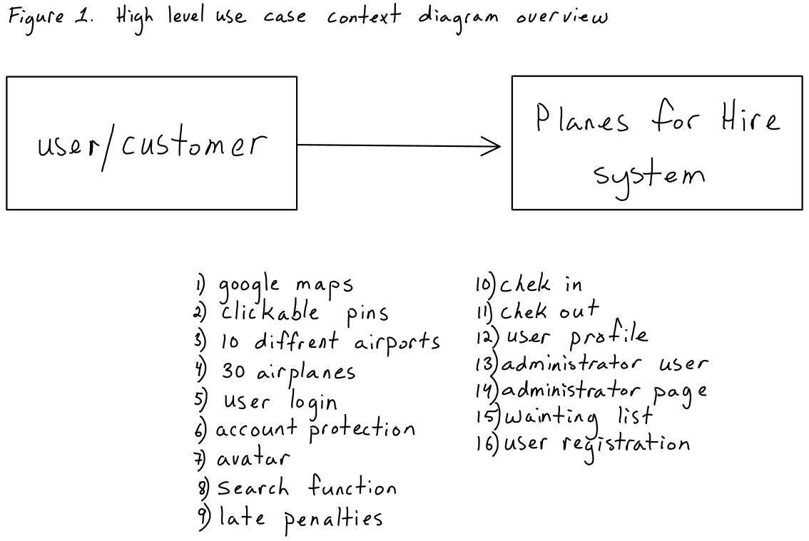

Figure 2. Use case 1, Google Maps

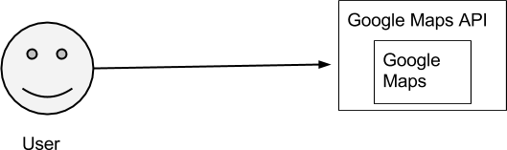

Figure 3. Use case 2, Clickable Pins

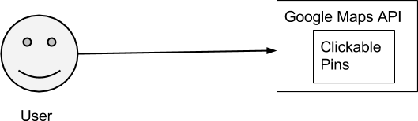

Figure 4. Use case 3, Airport

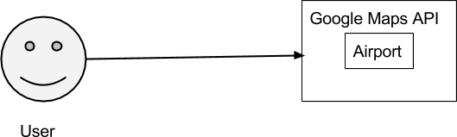

Figure 5. Use case 4, Airplane

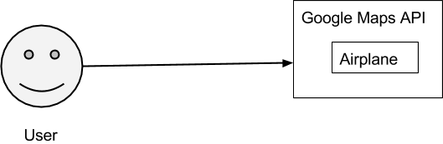

Figure 6. Use case 5, User Login

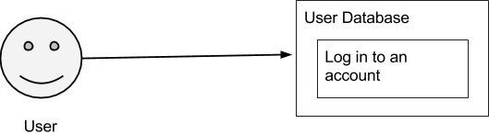

Figure 7. Use case 6, Account Protection

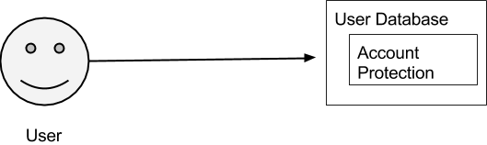

Figure 8. Use case 7, Profile Picture

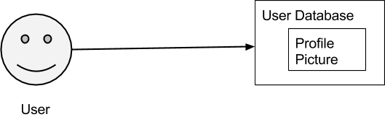

Figure 9. Use case 8, Search Function

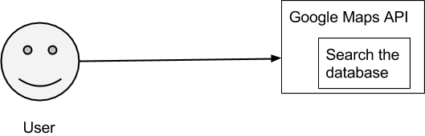

Figure 10. Use case 9, Late Penalties

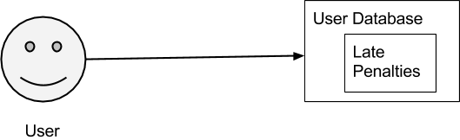

Figure 11. Use case 10, Check In

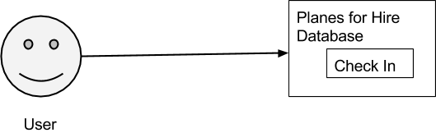

Figure 12. Use case 11, Check Out

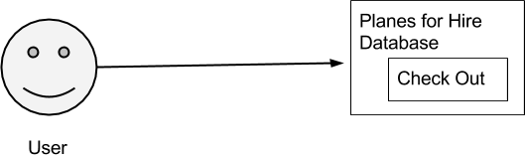

Figure 13. Use case 12, User Profile Page

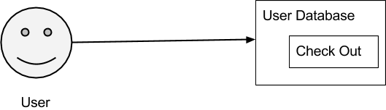

Figure 14. Use case 13, Administrative User

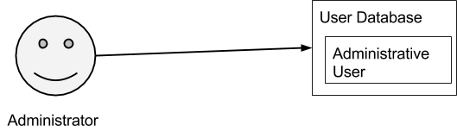

Figure 15. Use case 14, Administrative Page

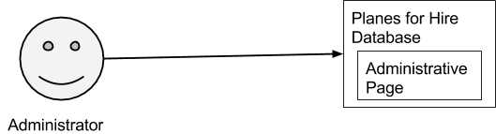

Figure 16. Use case 15, Waiting List

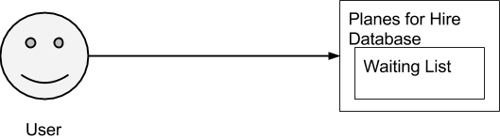

Figure 17. Use case 16, User Registration

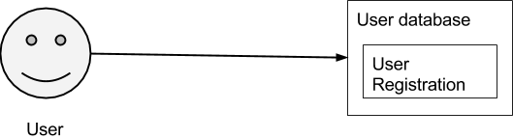

## 2. Functional Requirements

|  |  |  |
| --- | --- | --- |
| **Number** | 1 | |
| Name | Google Maps | |
| **Summary** | A top view of locations of airports near the user. It allows the user to see the time and distance to their destination. | |
| **Priority** | 5 | |
| **Preconditions** | User must be able to search for airports near them. | |
| **Postconditions** | It should show flight path for user selected destination | |
| **Primary Actor** | User | |
| **Secondary Actors** | Google maps server | |
| **Trigger** | Open web browser | |
| **Main Scenario** | **Step** | **Action** |
|  | 1 | Open the web browser |
|  |  |  |
|  |  |  |
| **Extensions** | **Step** | **Branching Action** |
|  |  | N/A |
| **Open Issues** | Server down, Internet issues | |

|  |  |  |
| --- | --- | --- |
| **Number** | 2 | |
| Name | Clickable pins | |
| **Summary** | Drop down pins for user selected source and destination | |
| **Priority** | 4 | |
| **Preconditions** | should drop a pin for the user selected source. | |
| **Postconditions** | Highlight the route of the destination where the two endpoint should have a drop pins | |
| **Primary Actor** | user | |
| **Secondary Actors** | Server | |
| **Trigger** | Search button. | |
| **Main Scenario** | **Step** | **Action** |
|  | 1 | Search source and destination |
|  | 2 | Click pins |
|  |  |  |
| **Extensions** | **Step** | **Branching Action** |
|  |  | N/A |
| **Open Issues** | Server problem, Connectivity issues | |

|  |  |  |
| --- | --- | --- |
| **Number** | 3 | |
| Name | Making planes | |
| **Summary** | Making 30 planes using an object class to simulate rentable planes | |
| **Priority** | 1 | |
| **Preconditions** | There must be an airport for the planes to be in | |
| **Postconditions** | There will be planes that are “flyable” and traceable. | |
| **Primary Actor** | The client | |
| **Secondary Actors** | < other systems that are relied upon to accomplish the use case > | |
| **Trigger** | Client rents a plane | |
| **Main Scenario** | **Step** | **Action** |
|  | 1 | User selects nearest airport |
|  | 2 | User selects destination |
|  | 3 | User takes a plane |
| **Extensions** | **Step** | **Branching Action** |
|  | 1a | N/A |
| **Open Issues** | If there is one plane at the airport then second user at the airport won’t be able to use the app. | |

|  |  |  |
| --- | --- | --- |
| **Number** | 4 | |
| Name | Making airports | |
| **Summary** | Making 10 airports that will simulate real locations where the planes can land. | |
| **Priority** | 2 | |
| **Preconditions** | There must be a location | |
| **Postconditions** | Planes can arrive and leave the airports | |
| **Primary Actor** | Planes leaving and arriving | |
| **Secondary Actors** | < other systems that are relied upon to accomplish the use case > | |
| **Trigger** | When a user searches for a flight path before arriving at the starting airport. | |
| **Main Scenario** | **Step** | **Action** |
|  | 1 | User searches for a location to fly to |
|  | 2 | The app tells users the nearest airport to fly from |
|  | 3 | User drives to airport |
| **Extensions** | **Step** | **Branching Action** |
|  | 1a | If the user selects an area where there are no airports then the app will display an airport closest to the user. |
| **Open Issues** | N/A | |

|  |  |  |
| --- | --- | --- |
| **Number** | 5 | |
| Name | User Login | |
| **Summary** | Having an easy to access login system incorporating a username and password | |
| **Priority** | 4 | |
| **Preconditions** | There must be a visible login/signup icon at the top right of the screen. User should be able to put in his/her username and password. | |
| **Postconditions** | User will be able to check in and check out planes after signing in. | |
| **Primary Actor** | Users of the website | |
| **Secondary Actors** | Database that keeps record of usernames and passwords. JSON was suggested to be a potential alternative. | |
| **Trigger** | Clicking on sign-in/login link and inputting username and password. | |
| **Main Scenario** | **Step** | **Action** |
|  | 1 | User clicks on sign-in/login at top right corner of screen. |
|  | 2 | User inputs valid username/email and password |
|  | 3 | User clicks sign-in/login button, and if all goes well, enters the main site. |
| **Extensions** | **Step** | **Branching Action** |
|  | 3a | If the user puts in an invalid username or password, they will be presented with an error. (I recommend that all text fields keep data stored to prevent user from having to insert them again) |
| **Open Issues** | Storing username and password information in a database or text files. | |

|  |  |  |
| --- | --- | --- |
| **Number** | 6 | |
| Name | Account Protection | |
| **Summary** | Running the security questions to check and protect customer information. | |
| **Priority** | 2 | |
| **Preconditions** | Question must be close and easy for user to input the answer. | |
| **Postconditions** | The answer must match to database to verify the user’s account. | |
| **Primary Actor** | account holder | |
| **Secondary Actors** | The information is saved in database. | |
| **Trigger** | pop a new site to ask user security question. | |
| **Main Scenario** | **Step** | **Action** |
|  | 1 | a new page will show up with multiple security questions. |
|  | 2 | Users pick and enter the question |
|  | 3 | Users click to verify and access their account |
| **Extensions** | **Step** | **Branching Action** |
|  | 1a | If there are 3 wrong answers are entered. The account will be temporarily blocked. |
| **Open Issues** | There will be symbol on special letter from the input’s user | |

|  |  |  |
| --- | --- | --- |
| **Number** | 7 | |
| Name | Profile Picture | |
| **Summary** | User who wants to post their picture to be used as profile picture. | |
| **Priority** | 1 | |
| **Preconditions** | User name must be highlighted or clickable to be able to edit | |
| **Postconditions** | It is easy to browse and post user’s picture | |
| **Primary Actor** | account holder | |
| **Secondary Actors** | It will be stored in the database. | |
| **Trigger** | Click on the user name | |
| **Main Scenario** | **Step** | **Action** |
|  | 1 | Click on user name to pop a medium window |
|  | 2 | Browse your picture and click Ok |
|  | 3 | Back to the main page with your picture posted. |
| **Extensions** | **Step** | **Branching Action** |
|  | 1a | The picture maybe over sized of the designed window. |
| **Open Issues** | There are so many types of picture’s file such as pn, jig | |

|  |  |  |
| --- | --- | --- |
| **Number** | 8 | |
| Name | Search function | |
| **Summary** | User can use this tool to search for airport | |
| **Priority** | 4 | |
| **Preconditions** | User enter a location name in the search field | |
| **Postconditions** | Displays results of all nearby airports | |
| **Primary Actor** | Any anonymous user | |
| **Secondary Actors** | Database server | |
| **Trigger** | User click on the search button | |
| **Main Scenario** | **Step** | **Action** |
|  | 1 | User enter in a value in the text field |
|  | 2 | User click on the search button |
|  | 3 | Search result displayed |
| **Extensions** | **Step** | **Branching Action** |
|  | 2a | user click on search button without value in text field, no result displayed |
| **Open Issues** | User enter zip code of city to search instead of city names | |

|  |  |  |
| --- | --- | --- |
| **Number** | 9 | |
| Name | Late Penalties | |
| **Summary** | Penalties given to users who fail to do task by assigned date. | |
| **Priority** | 4 | |
| **Preconditions** | User fails to acquire plane on designated date, or fails to check out in a timely manner. | |
| **Postconditions** | Penalty is given to user. | |
| **Primary Actor** | User checking in or out an airplane. | |
| **Secondary Actors** | Companies using online airplane service as a way of managing customers. | |
| **Trigger** | User showing up late or not at all, or failing to check out plane, | |
| **Main Scenario** | **Step** | **Action** |
|  | 1 | User registers plane online. |
|  | 2 | Shows up on assigned date |
|  | 3 | User arrives to destination on time, but fails to check out plane. Penalty is given. |
| **Extensions** | **Step** | **Branching Action** |
|  | 2a | If user does not show up on assigned date, or not at all, a penalty is given. |
| **Open Issues** | Determining what sort of penalty is given for each misuse of company resources. | |

|  |  |  |
| --- | --- | --- |
| **Number** | 10 | |
| Name | Check In | |
| **Summary** | Allow users to check in Airplanes from different airport location | |
| **Priority** | 5 | |
| **Preconditions** | To check in, the user needs to have an airplane. | |
| **Postconditions** | User should be able to check in airplanes. | |
| **Primary Actor** | User checking in an airplane. | |
| **Secondary Actors** | Companies using online airplane service as a way of managing customers. | |
| **Trigger** | Check In Button | |
| **Main Scenario** | **Step** | **Action** |
|  | 1 | User logs in |
|  | 2 | User searches for the nearest airport and airplanes |
|  | 3 | User check in the the airplane at any airport. |
| **Extensions** | **Step** | **Branching Action** |
|  | 2a | N/A |
| **Open Issues** | Misuse of planes or damage occurred to airplanes. | |

|  |  |  |
| --- | --- | --- |
| **Number** | 11 | |
| Name | Check Out | |
| **Summary** | Allow users to check out Airplanes from different airport location | |
| **Priority** | 5 | |
| **Preconditions** | To check you, the airplanes must be available at the airport. | |
| **Postconditions** | User should be able to check out airplanes. | |
| **Primary Actor** | User checking out an airplane. | |
| **Secondary Actors** | Companies using online airplane service as a way of managing customers. | |
| **Trigger** | Check In/Check Out Button | |
| **Main Scenario** | **Step** | **Action** |
|  | 1 | User login in |
|  | 2 | User searches for the nearest airport and airplanes |
|  | 3 | User checks out an airplane. |
| **Extensions** | **Step** | **Branching Action** |
|  | 2a | If no airplanes are available then put the user on hold. |
| **Open Issues** | N/A | |

|  |  |  |
| --- | --- | --- |
| **Number** | 12 | |
| Name | User Profile Page | |
| **Summary** | Actions users can take when they reach their profile page. | |
| **Priority** | 2 | |
| **Preconditions** | User queries for account information | |
| **Postconditions** | Data is received and shown | |
| **Primary Actor** | User making change. | |
| **Secondary Actors** | Server updating change. | |
| **Trigger** | User simply logging in, or making a query for a specific piece of data. | |
| **Main Scenario** | **Step** | **Action** |
|  | 1 | User queries account information. |
| **Extensions** | **Step** | **Branching Action** |
|  | 1a | User is given account settings on request. (IE automatic email updates, PM information, etc) |
|  | 1b | User is shown all current and past plane transactions. |
| **Open Issues** |  | |

|  |  |  |
| --- | --- | --- |
| **Number** | 13 | |
| Name | Administrative User | |
| **Summary** | Can access the administration page. Can add planes/airports if necessary. | |
| **Priority** | 4 | |
| **Preconditions** | N/A | |
| **Postconditions** | Has access to the administration page | |
| **Primary Actor** | Administrator | |
| **Secondary Actors** | N/A | |
| **Trigger** | Administrator logs in | |
| **Main Scenario** | **Step** | **Action** |
|  | 1 | Administrator logs in |
|  | 2 | Has access to administration page |
| **Extensions** | **Step** | **Branching Action** |
|  | 1a | N/A |
| **Open Issues** | If the administrator is flag as a user and can’t access the admin page | |

|  |  |  |
| --- | --- | --- |
| **Number** | 14 | |
| Name | Administrative Page | |
| **Summary** | Displays all users who exist in the database. Shows which users have checked out a plane. Shows which users are in a waiting list. Planes/airports can be added. | |
| **Priority** | 4 | |
| **Preconditions** | Administrator requests page access | |
| **Postconditions** | Administrator has access to the page | |
| **Primary Actor** | Administrator | |
| **Secondary Actors** | Planes for Hire database | |
| **Trigger** | Administrator logs in | |
| **Main Scenario** | **Step** | **Action** |
|  | 1 | Administrator logs in |
|  | 2 | Administrator accesses page |
|  | 3 | Page is displayed |
| **Extensions** | **Step** | **Branching Action** |
|  | 3a | Administrator adds plane/airports to the page |
| **Open Issues** | Normal users must be flagged so they won’t have access to the admin page. | |

|  |  |  |
| --- | --- | --- |
| **Number** | 15 | |
| Name | Waiting List | |
| **Summary** | Put user on waiting list if user checks out and a requested plane is not available | |
| **Priority** | 4 | |
| **Preconditions** | User checks out and a plane is not available | |
| **Postconditions** | Put user on the next available slot on the waiting list | |
| **Primary Actor** | User checks out a plane | |
| **Secondary Actors** | Application database | |
| **Trigger** | User decides to check out by clicking the checkout button | |
| **Main Scenario** | **Step** | **Action** |
|  | 1 | User click checkout button |
|  | 2 | Application checks planes database |
|  | 3 | Application checks waiting list database |
|  | 4 | Application tells user their position in line |
|  | 5 | Application add user to waiting list |
| **Extensions** | **Step** | **Branching Action** |
|  | 4a | user cancel from added to waiting list |
| **Open Issues** | Allow user ability to be drop from waiting list | |

|  |  |  |
| --- | --- | --- |
| **Number** | 16 | |
| Name | User Registration | |
| **Summary** | Allow user to register an account with the application | |
| **Priority** | 5 | |
| **Preconditions** | User clicks on the register link | |
| **Postconditions** | User successfully creates an account | |
| **Primary Actor** | The user | |
| **Secondary Actors** | Application database | |
| **Trigger** | User decides to click on the register link | |
| **Main Scenario** | **Step** | **Action** |
|  | 1 | User click on the register link |
|  | 2 | Application loads registration page |
|  | 3 | User enters their information |
|  | 4 | Application adds user to database |
| **Extensions** | **Step** | **Branching Action** |
|  | 4a | User name already exists in database |
| **Open Issues** | Allow user to close account | |

## 3. Non-Functional Requirements

## 

|  |  |  |
| --- | --- | --- |
| # | Item | Priority 1(lowest) 5 (highest) |
| 1 | Server-side code written in php. | 5 |
| 2 | Server is safe and secure from attacks | 2 |
| 3 | Homepage is well formatted and aesthetically pleasing. | 4 |
| 4 | Website is easy to navigate | 2 |
| 5 | Code is well documented | 2 |
| 6 | Server is an Apache server | 5 |
| 7 | Server communicates with MySql database to store user information. | 3 |
| 8 | Server quickly responds to queries | 2 |
| 9 | Server code is portable | 2 |
| 10 | Server is scalable. | 3 |
| 11 | Use four spaces for indentation | 2 |

## 

## 

## 4. User Interface

See “User Interface Design Document for *Planes for Hire*.”

## 5. Deliverables

Deliverables include:

* Systems Requirement Specification
* System Design Document
* User Interface Design Document
* Copies of all weekly Status Reports

A CD (or electronic copy in a ZIP file) containing the following:

* Systems Requirement Specification
* System Design Document
* User Interface Design Document
* User Manual
* Administrator Manual
* All source code
* The executable program
* Any other software required for installation and execution of the delivered program.

## 6. Open Issues

Issues that have been raised and do not yet have a conclusion. These issues will be addressed later in the development process. Please refer to the table below.

|  |  |
| --- | --- |
| **Issues** | **Scheduled for** |
| Setting up server on a host. | Spiral 2 |
| Setting up a database. | Spiral 2 |
| Building website pages. | Spiral 2 |
| Connecting to Google Maps API, Twitter API, etc | Spiral 2 |

## 7. Appendix A – Agreement Between Customer and Contractor

The customer agrees to a Planes For Hire web application with searching, google maps, and user accounts with security encryption capabilities. Use cases are included in the functional requirements section above of the behavior between the system and user. Additional features will be provided in further development spirals.

When and if future changes to this document occur a drafted new document will be created. Both a hard and electronic copy of both versions will be presented to the client for review. Upon approval, the draft will be finalized and signed off by both parties.

**Client**

**Name ___________________________________________________**

**Date ____________________________________________________**

**Sign _____________________________________________________**

**Team**

**Name ___________________________________________________**

**Date ____________________________________________________**

**Sign _____________________________________________________**

**Name ___________________________________________________**

**Date ____________________________________________________**

**Sign _____________________________________________________**

**Name ___________________________________________________**

**Date ____________________________________________________**

**Sign _____________________________________________________**

**Name ___________________________________________________**

**Date ____________________________________________________**

**Sign _____________________________________________________**

**Name ___________________________________________________**

**Date ____________________________________________________**

**Sign _____________________________________________________**

## 8. Appendix B – Team Review Sign-off

This document has been collaboratively written by all members the team. Additionally, all team members have reviewed this document and agree on both the content and the format. Any disagreements or concerns are addressed in team comments below.

**Team**

**Name ___________________________________________________**

**Date ____________________________________________________**

**Sign _____________________________________________________**

**Comments _________________________________________________________________**

**_________________________________________________________________**

**_________________________________________________________________**

**Name ___________________________________________________**

**Date ____________________________________________________**

**Sign _____________________________________________________**

**Comments _________________________________________________________________**

**_________________________________________________________________**

**_________________________________________________________________**

**Name ___________________________________________________**

**Date ____________________________________________________**

**Sign _____________________________________________________**

**Comments _________________________________________________________________**

**_________________________________________________________________**

**_________________________________________________________________**

**Name ___________________________________________________**

**Date ____________________________________________________**

**Sign _____________________________________________________**

**Comments _________________________________________________________________**

**_________________________________________________________________**

**_________________________________________________________________**

**Name ___________________________________________________**

**Date ____________________________________________________**

**Sign _____________________________________________________**

**Comments _________________________________________________________________**

**_________________________________________________________________**

**_________________________________________________________________**

## 9. Appendix C – Document Contributions

Sundar Sekar took the lead on the writing of this document with creating the document on google drive and sharing with the team members. He began the writing of the use cases and other functional requirements,introduction, appendices A and C and created table of contents with hyperlinks. He played a major part in assembling and reviewing the document. Robert Melgar contributed by writing use cases, appendices B, adding to non-functional requirements, document formatting as well as creating the UML. Tam Tran contributed by creating product scope, diagrams, introduction and use cases. William Andrew Cahill contributed by creating open issues, use cases, and deliverables. Du Nguyen contributed with uses cases.